**IT161 LAB** **2**   
  
Name : Snehal Nalawade  
Student ID : 202151160  
Date : 07/01/2022

**Topic** : Ramesh’s basic salary is input through the keyboard. His dearness allowance is 40% of the basic salary and house rent allowance is 20% of basic salary. Write an algorithm, flowchart and program to calculate his gross salary.

**Objective** : To write a C program to input basic salary from the user and display the gross salary on the screen.

**Software :** Online GDB Compiler and debugger for C (IDE)

**Methodology :** The program is written such that when executed, it takes Basic salary(BS) as input from the user. The variable storing the value of basic salary is declared to be of float data type so that the user can enter decimal values too.

After the input is taken, the values of dearness allowance(DA) and house rent allowance(HRA) are calculated, given that:

DA = (40/100)*BS , and

HRA = (20/100)*BS

Thereafter, the gross salary(GS) is calculated, where

GS = BS +DA +HRA

The calculated gross salary is then displayed on the screen.

**Algorithm of the program :**

* Step 1 : Start
* Step 2 : declare and initialize float type variables BS, DA, HRA and GS
* Step 3 : take basic salary (BS) as input from the user
* Step 4 : calculate the dearness allowance (DA) and house rent allowance (HRA)
* Step 5 : BS + DA + HRA 🡪 gross salary (GS)
* Step 6 : display the gross salary (GS)
* Step 7 : Stop

**Flowchart of the program :**

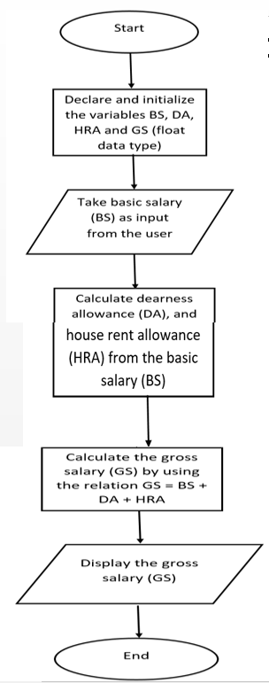

**Source code of the C program :**

**/* This C program is prepared by Snehal Nalawade**

**Roll No : 202151160**

**Date of preparation : 04/01/2022**

**this program takes basic salary(BS) as input from the user; calculates the dearness allowance(DA),**

**house rent allowance(HRA) and the gross salary(GS) and then displays the gross salary */**

#include <stdio.h>

int main()

{

float BS = 0.00; **//declaring and initializing the variables**

float DA = 0.00;

float HRA = 0.00;

float GS = 0.00;

printf("Enter the Basic Salary :");

scanf("%f", &BS); **/*taking basic salary as input from the user and storing it in the variable BS */**

DA = (40*BS)/100; **//calculating the dearness allowance**

HRA = (20*BS)/100; **//calculating the house rent allowance**

GS = BS + DA + HRA; **//calculating the gross salary**

printf("Your Gross Salary is : %.2f ",GS); **/* displaying the gross salary upto two decimal places */**

return 0;

}

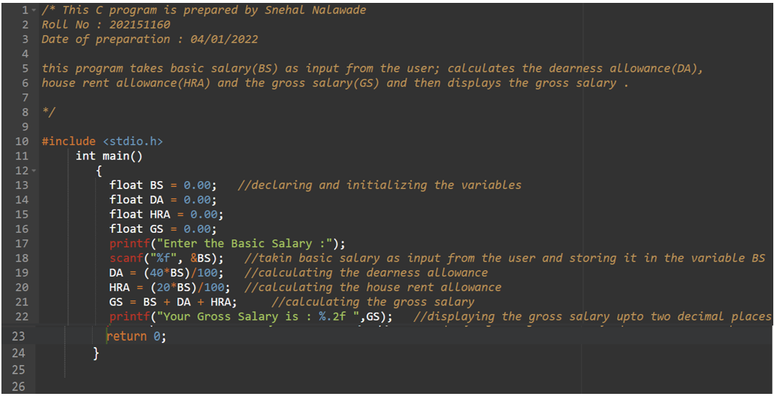

**Outputs after executing the C program :**

**Sample 1)** Enter the Basic Salary : 12000 🡪 input

Your Gross Salary is : 19200.00 🡪 output

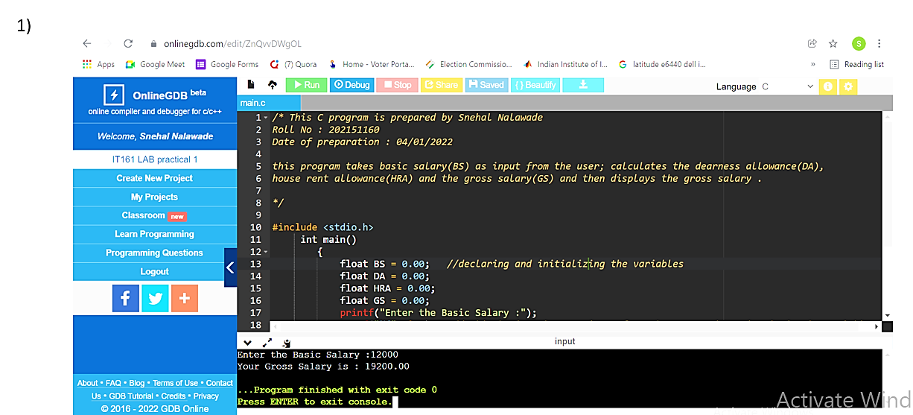

**Sample 2)** Enter the Basic Salary : 30000 🡪 input

Your Gross Salary is : 48000.00 🡪 output

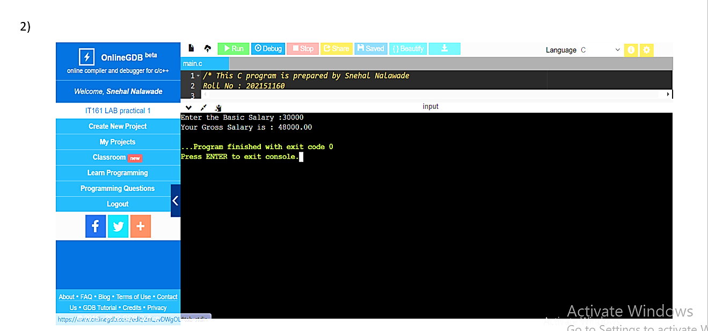

**Conclusion :** The C Code has been executed successfully and the desired results are obtained.

**Thank you**